Website joy

Web contrnt

Weibo、Wechat、ins account

Only my name. No other information

My logo (Maybe 2 or 3)

My paintings

My poem (maybe some strange sentence)

chat window

My artwork or idea or sketch

I want to be a mysterious person on my website

Recipe

Books and movie sharing

My site will be diverse, it is not limited to one property

Images

Gif jpeg png

1024\*780 800\*600 200\*160

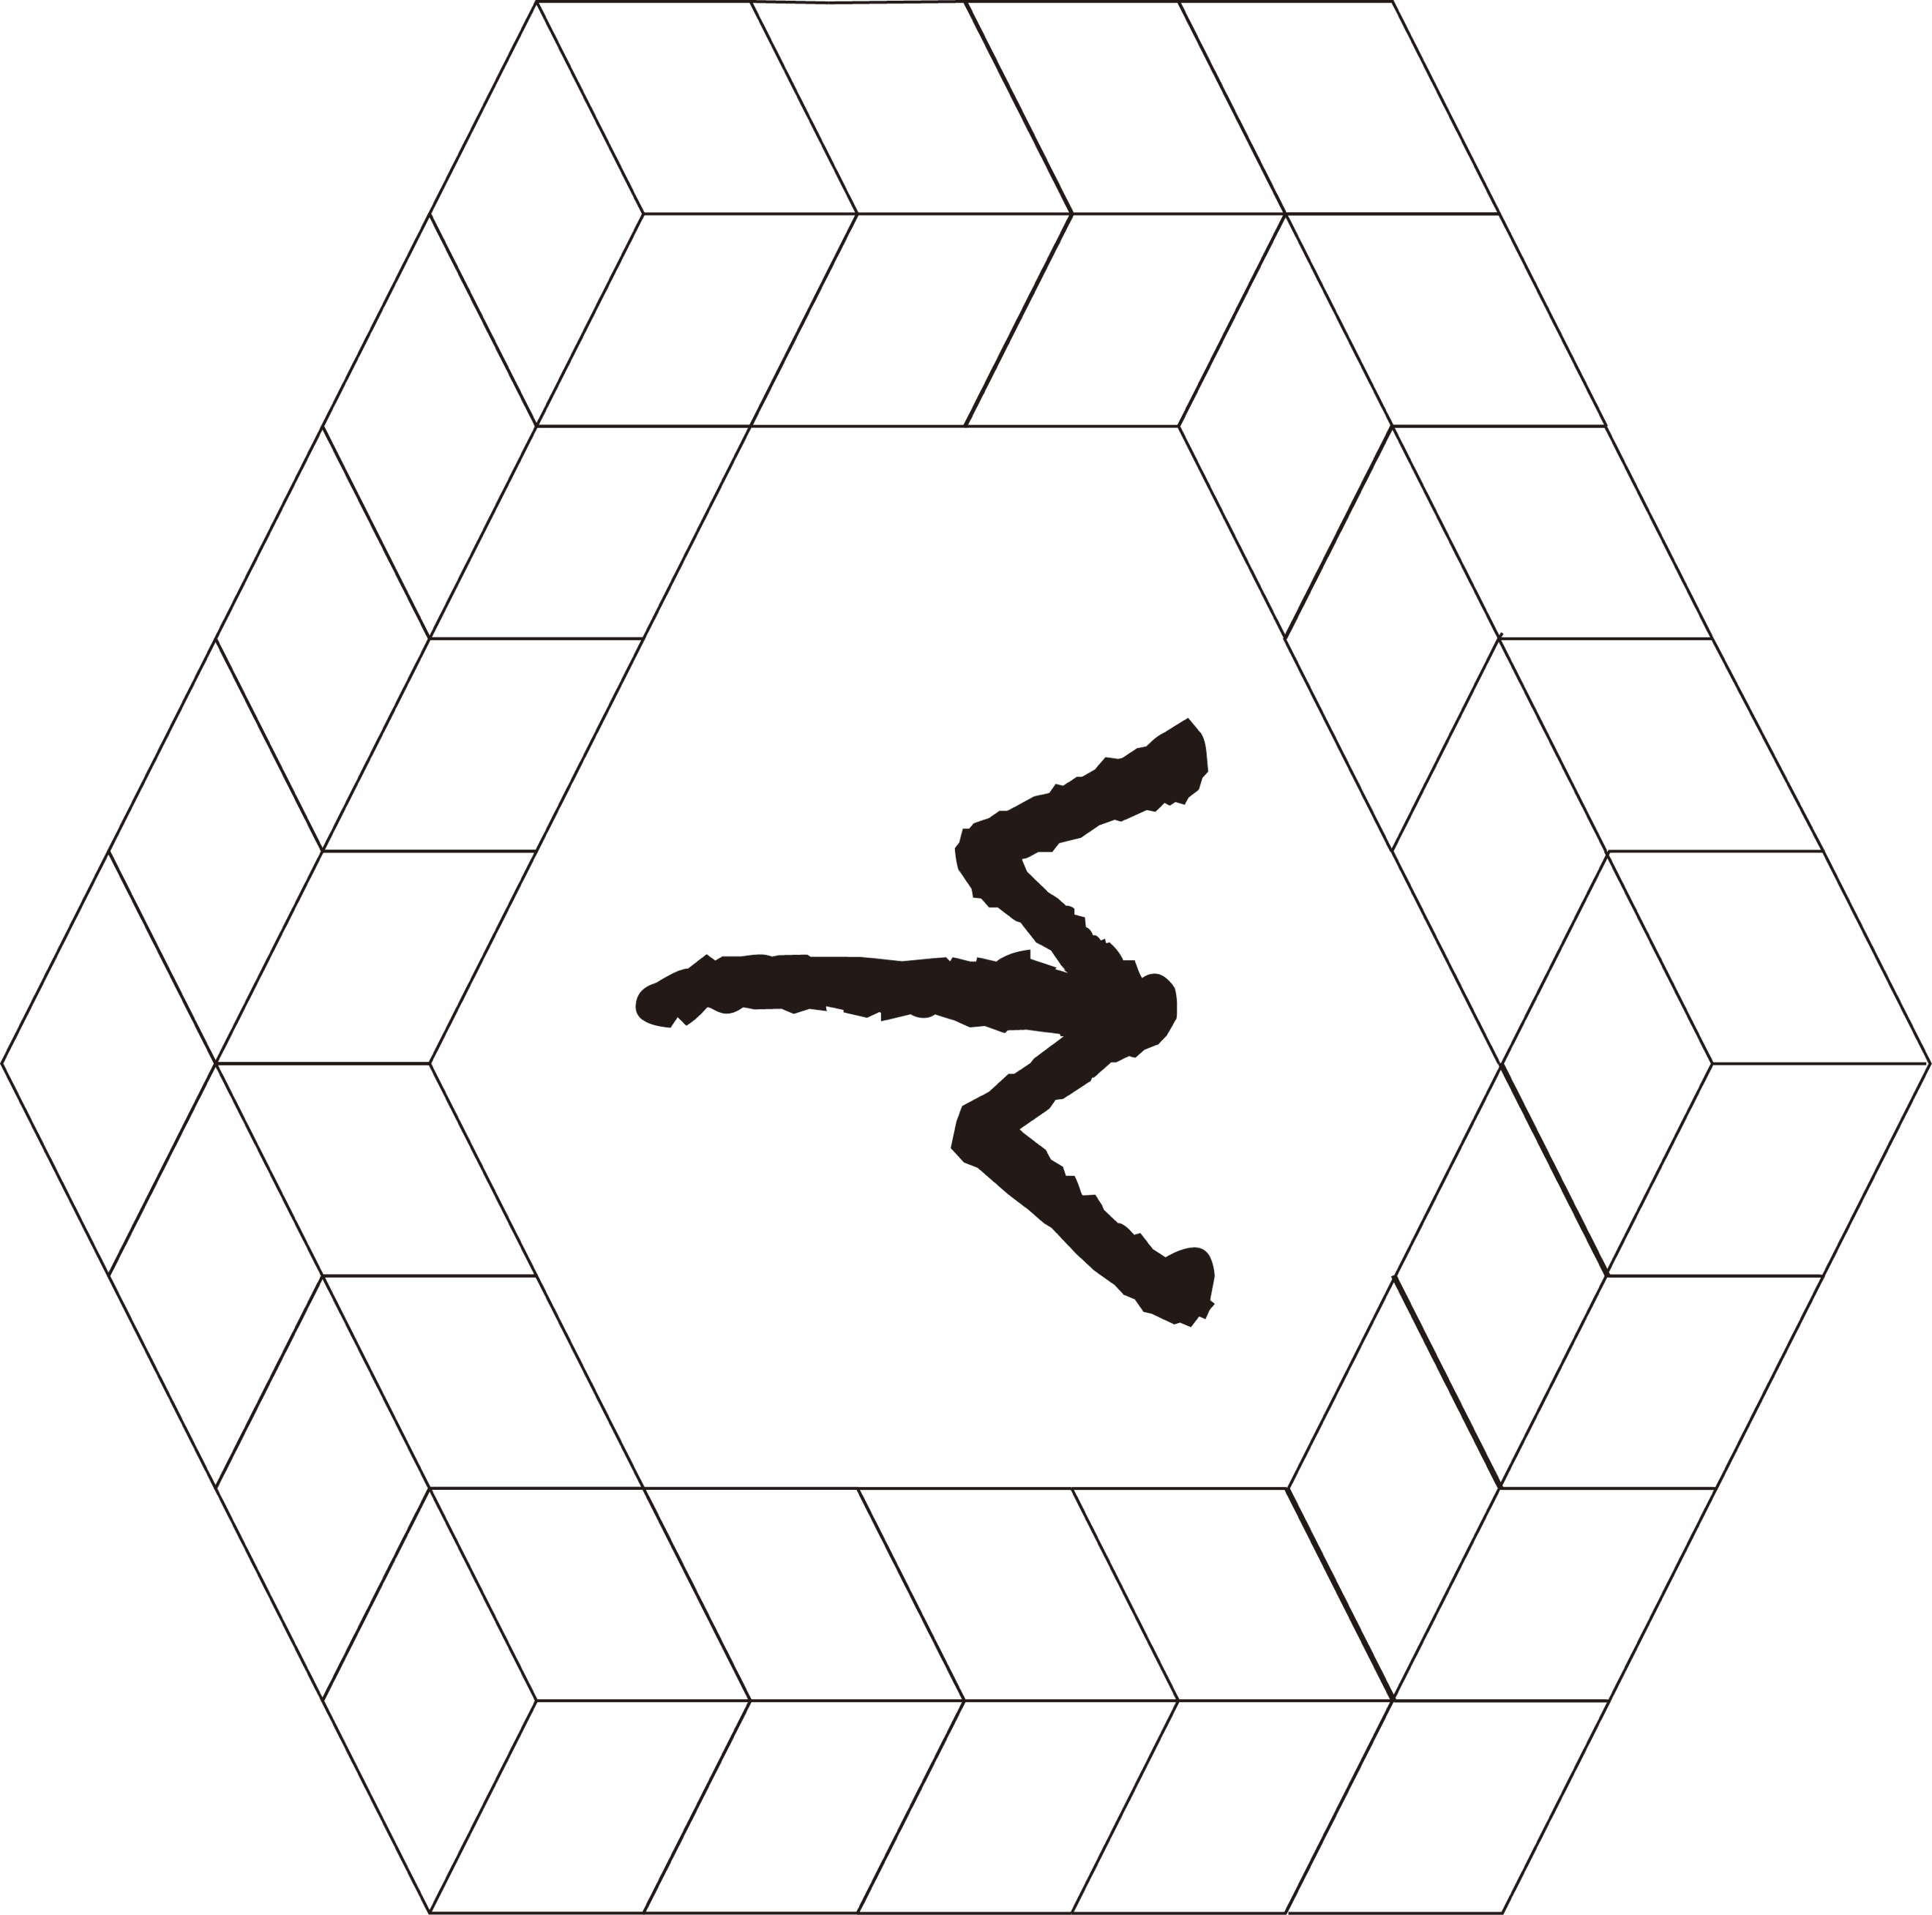

External link

<http://ubu.com>

http://reas.com